assignment 5
1.critical hypothesis: People who have dorm-cleaning issues are willing to use our platform.

2.Target users and recruitment criteria: People with cleaning problems in dorms

3.Test method and main metric: I interviewed 5 target users to score how severe the cleaning problems are in their dorms, if they hope to change it right now and what is their recent methods to dealing with this problem.

4.pre-set success/failure threshold:
if there is score of the severity is higher than three of five and that of the hopeness is also higher than three of five and their recent methods is inconvinent, our assumption is true. Otherwise, it fails.

5.Raw results or key evidence:

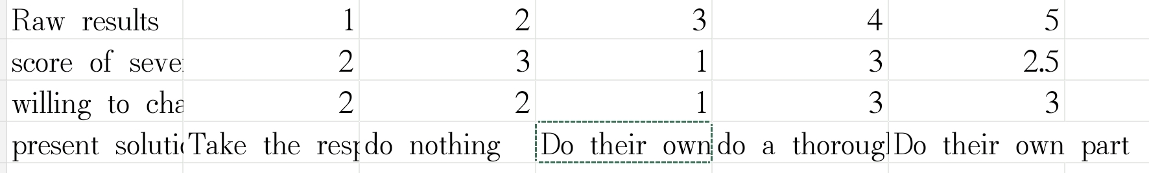
Present solution: Two students only clean their own parts. One take the responsibility to clean the public area. One be on duty for a week. But there is no administrator so it disappear after some times. One follow the whoever dirtied it should clean it up rule.

6.The average score is 2.25 but there is score of the severity is higher than three of five and that of the hopeness is also higher than three of five. What is more, they do not have a convinent solution. This shows a requirement in dorm cleaning for people without a efficient solution. However, for people aready deal with the problems, we still need to figure out what is their solution to this problem to make sure our solution has some aspect that better than their's.

7.next decision: we can interview people who apply other solutions to check if our solution have advantage, although they may not be our target customers.

